

10/05/2024

**Assignment Report (6&7)**

***Orthographic projections***

Assignment # 1

AUTO CAD

|  |  |
| --- | --- |
| NAME | CMS |
| Rana Muhammad Abdullah | 468092 |

**AE-01  
  
COURSE** **TITLE:** Engineering Drawing   
**SEMESTER:** 2nd**SESSION:** Spring 2024

# Figure 1:

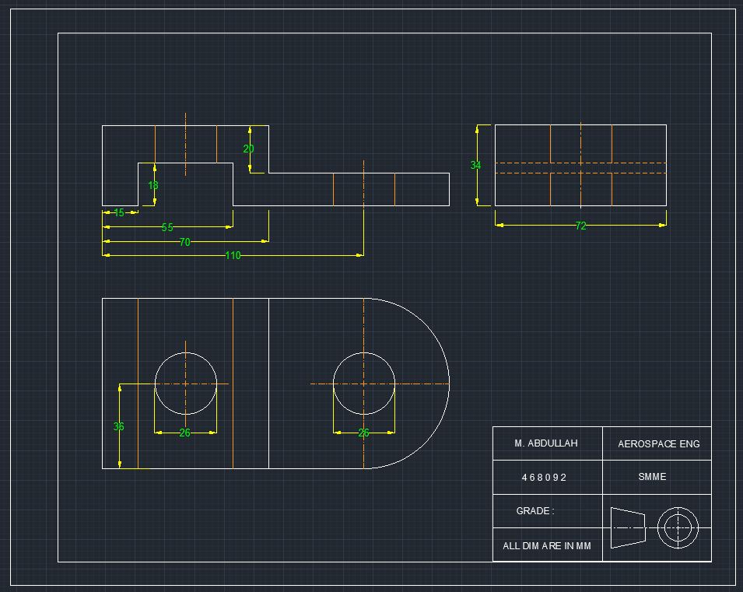

# Figure 2:

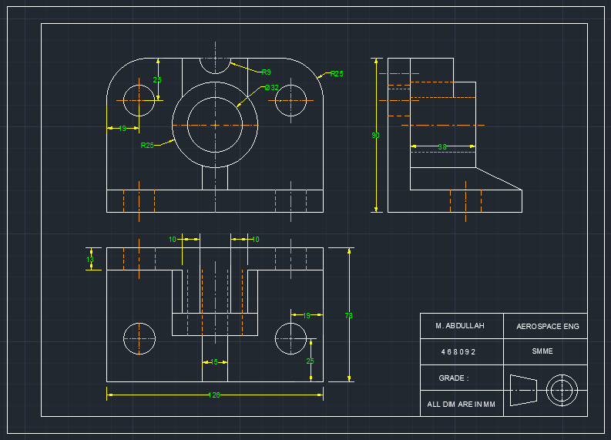

# Figure 3:

